Budget Tracker

Server Specification  
*Created by Stanley Fuller*

Table of Contents

Type Definitions 3

Database Design 4

API Paths 5

Overview 5

Detailed 6

/get_access_token 6

/change_password 6

/register_user 6

/list/budgets 7

/add/budget 7

/delete/budget/{budget_id} 7

/get/budget/{budget_id} 8

/access/budget/list/{budget_id} 8

/access/budget/add/{budget_id} 8

/access/budget/remove/{budget_id} 9

/list/transactions/{budget_id} 9

/list/current/transactions/{budget_id} 9

/list/between/transactions/{budget_id} 10

/add/transaction 10

/delete/transaction/{transaction_id} 10

/get/transaction/{transaction_id} 11

# Type Definitions

enum ResultStatus {

Success,

InvalidCredentials,

AccessTokenExpired,

EntryDoesNotExist,

Error(error: String),

}

AccessTokenForm {

“access_token”: String

}

StatusResult {

“status”: ResultStatus

}

SelectForm {  
 “access_token”: String,

“id”: i64

}

# Database Design

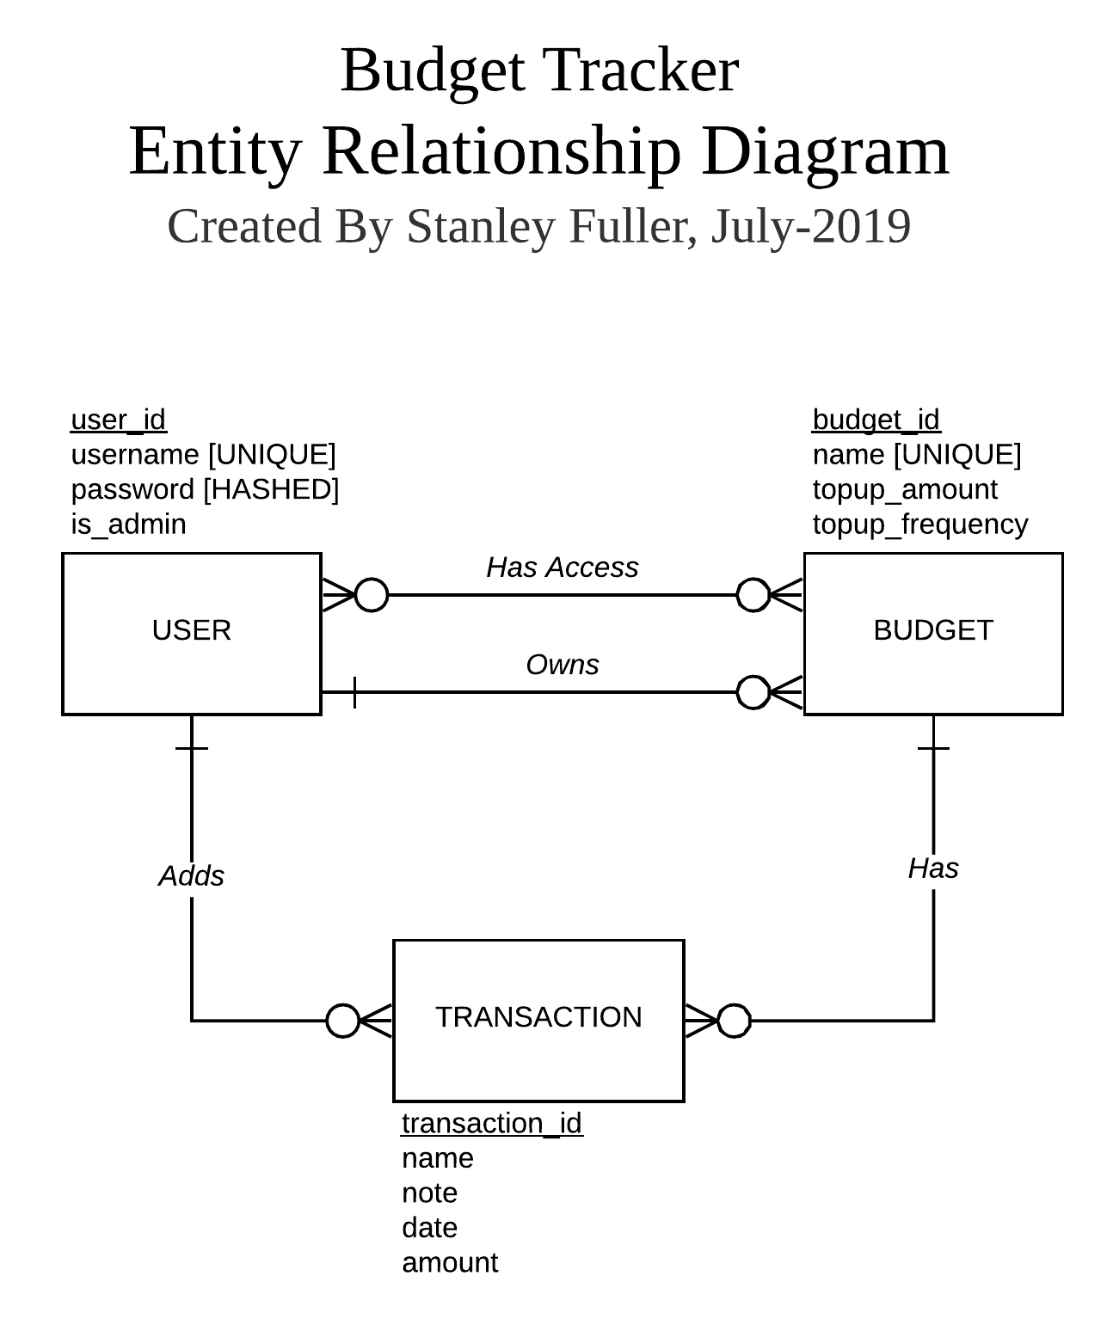

# API Paths

## Overview

|  |  |  |
| --- | --- | --- |
| Path | Description | More Detail |
| /get_access_token | Returns a valid access code if the provided login details are correct. | […] |
| /change_password | Changes the password of the current user and returns an updated access token. | [...] |
| /register_user | Registers an account with the given details. | [...] |
| /list/budgets | Returns a list of all budgets available to the user. | [...] |
| /add/budget | Create a new budget and return its ID. | [...] |
| /delete/budget/{budget_id} | Deletes the budget with the given ID. | […] |
| /get/budget/{budget_id} | Get the budget with the given ID and return its properties. | […] |
| /access/budget/list/{budget_id} | Displays a list of all users who have access to the budget. | […] |
| /access/budget/add/{budget_id} | Gives access to the given budget ID from the given user. | […] |
| /access/budget/remove/{budget_id} | Removes access to the given budget ID from the given user. | […] |
| /list/transactions/{budget_id} | Returns a list of all transactions in the budget. | […] |
| /list/current/transactions/{budget_id} | Returns a list of all transactions in the current time period. | […] |
| /list/between/transactions/{budget_id} | Returns a list of transactions within a supplied date range. | […] |
| /add/transaction | Add a transaction with the given properties and return its ID. | […] |
| /delete/transaction/{transaction_id} | Deletes the transaction with the given ID. | […] |
| /get/transaction/{transaction_id} | Get the transaction with the given ID and return its properties. | […] |

## Detailed

### /get_access_token

Returns a valid access code if the provided login details are correct.

#### Input Body

CredentialForm {

“username”: String,

“password”: String

}

#### Output Body

AccessTokenResult {

“status”: ResultStatus,  
 “access_token”: Option<String>

}

### /change_password

Changes the password of the current user and returns an updated access token.

#### Input Body

ChangePasswordForm {

“access_token”: String,

“current_password”: String

“new_password”: String

}

#### Output Body

AccessTokenResult {

“status”: ResultStatus,  
“access_token”: Option<String>

}

### /register_user

Registers an account with the given details.

#### Input Body

RegisterAccountForm {

“username”: String

“password”: String

}

#### Output Body

AccessTokenResult {

“status”: ResultStatus,  
“access_token”: Option<String>

}

### /list/budgets

Returns a list of all budgets available to the user. If the current user is an administrator, then they can view all budgets.

#### Input Body

AccessTokenForm {

“access_token”: String

}

#### Output Body

BudgetListResult {

“status”: ResultStatus,  
“budgets”: Option<Vec<Budget>>

}

### /add/budget

Create a new budget with the current user as its owner and return its ID.

#### Input Body

AddBudgetForm {  
 “access_token”: String,

“budget_name”: String,

“budget_period_length”: i64

}

#### Output Body

BudgetResult {

“status”: ResultStatus,  
“budget”: Option<Budget>

}

### /delete/budget

Delete the budget with the given ID.

#### Input Body

SelectForm {  
 “access_token”: String,

“id”: i64

}

#### Output Body

StatusResult {

“status”: ResultStatus

}

### /get/budget

Get the budget with the given ID and return it.

#### Input Body

SelectForm {  
 “access_token”: String,

“id”: i64

}

#### Output Body

BudgetResult {

“status”: ResultStatus,

“budget”: Option<Budget>

}

### /list/can_access_budget

Displays a list of all users who have access to the budget, including the budget owner.

#### Input Body

SelectForm {  
 “access_token”: String,

“id”: i64

}

#### Output Body

UserListResult {

“status”: ResultStatus,

“users”: Option<Vec<String>>

}

### /add/can_access_budget

Gives access to the given budget ID from the given user.

Note #1: this user cannot be the budget owner.

Note #2: only the owner can give access to other users.

#### Input Body

CanAccessBudgetForm {  
 “access_token”: String,

“username”: String

“budget_id”: i64

}

#### Output Body

StatusResult {

“status”: ResultStatus

}

### /delete/can_access_budget

Removes access to the given budget ID from the given user.

Note #1: this user cannot be the budget owner.

Note #2: only the owner can remove access from other users (except if the username is the current user).

#### Input Body

CanAccessBudgetForm {  
 “access_token”: String,

“username”: String

“budget_id”: i64

}

#### Output Body

StatusResult {

“status”: ResultStatus

}

### /list/transactions

Returns a list of all transactions in the budget.

#### Input Body

ListTransactionsForm {  
 “access_token”: String

}

#### Output Body

ListTransactionsResult {

“status”: ResultStatus,

“transactions”: Option<Vec<Transaction>>

}

### /list/period/transactions/{budget_id}

Returns a list of all transactions in the current time period.

#### Input Body

AccessTokenForm {  
 “access_token”: String

}

#### Output Body

ListTransactionsResult {

“status”: ResultStatus,

“transactions”: Option<Vec<Transaction>>

}

### /list/between/transactions/{budget_id}

Returns a list of transactions within a supplied date range.

#### Input Body

ListTransactionsBetweenForm {  
 “access_token”: String,

“date_a”: String,

“date_b”: String

}

#### Output Body

ListTransactionsResult {

“status”: ResultStatus,

“transactions”: Option<Vec<Transaction>>

}

### /add/transaction

Add a transaction with the given properties and return it.

#### Input Body

AddTransactionForm {  
 “access_token”: String,

“name”: String,

“note”: String,

“date”: Option<String>, **Note: If field is ‘None’ then current day is assumed**

“amount”: f32

}

#### Output Body

AddTransactionResult {

“status”: ResultStatus,

“transaction”: Option<Transaction>

}

### /delete/transaction/{transaction_id}

Deletes the transaction with the given ID.

#### Input Body

AccessTokenForm {  
 “access_token”: String

}

#### Output Body

StatusResult {

“status”: ResultStatus

}

### /get/transaction/{transaction_id}

Get the transaction with the given ID and return its properties.

#### Input Body

AccessTokenForm {  
 “access_token”: String

}

#### Output Body

GetTransactionResult {

“status”: ResultStatus,

“transaction”: Option<Transaction>

}